**Installing “CentOS-7.x” on VMware Environment**

Hi… here I am installing CentOS-7.x on **Esxi** which is VMware environment, you can follow the same steps to install on physical also with ISO file. Or you can do the same thing in VMware workstation also the steps as follows.

**Requirements:**

ESXI installed VMware environment or you can use VMware Work station as well,

CentOS-7.x ISO file.

Let’s begin….

Right click on the host and click on **create new virtual machine** that results as below and click on **typical** if it is not selected, and click on **next** as below,

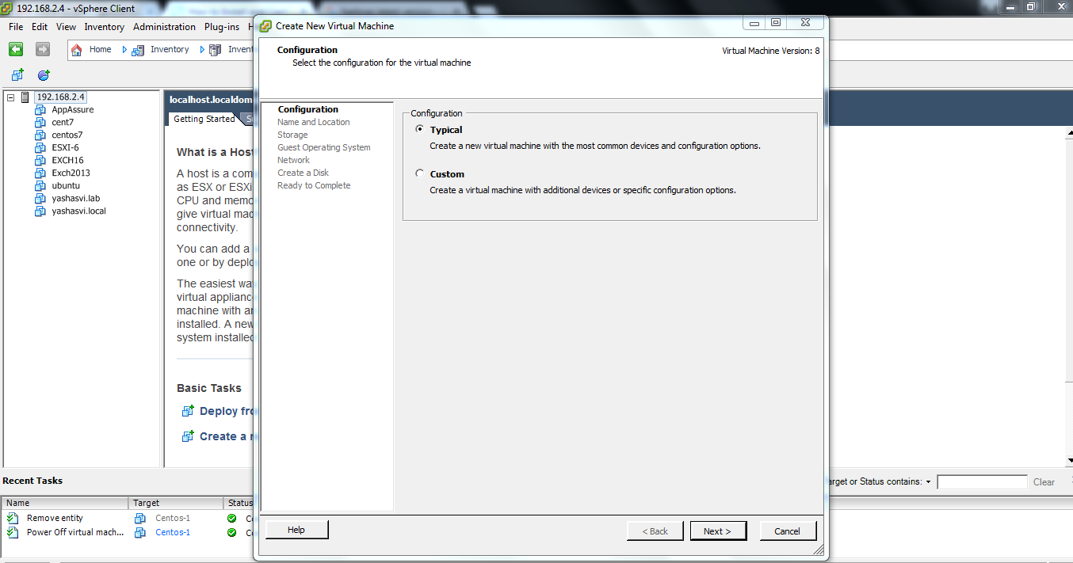

Name the virtual machine as below and click **next**

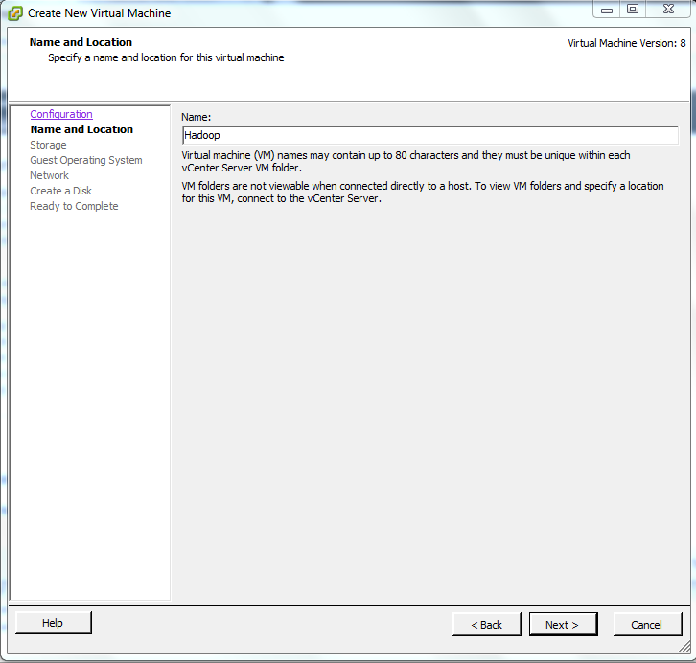

That results as below and select the storage where you want to store the virtual machine file(vmdk) as shown below,

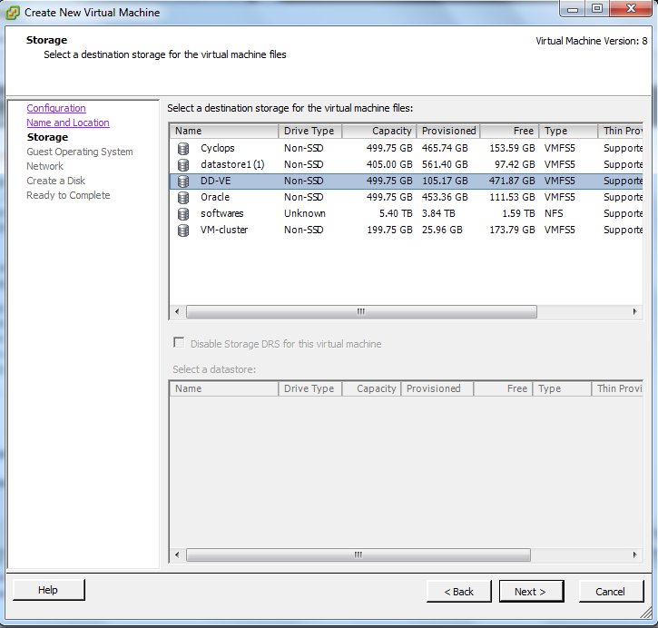

Then click on **next**  then select type of operating system you want to

Install and click **next**

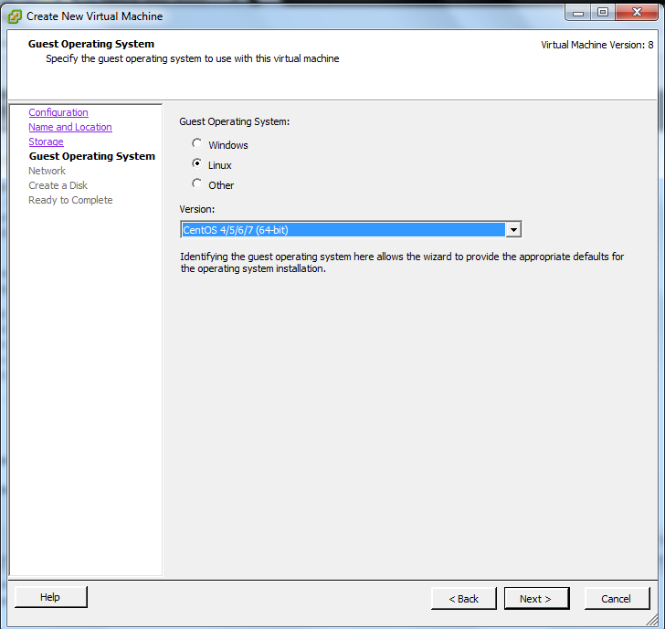

Then add the number of network adapters you want as below, then click next

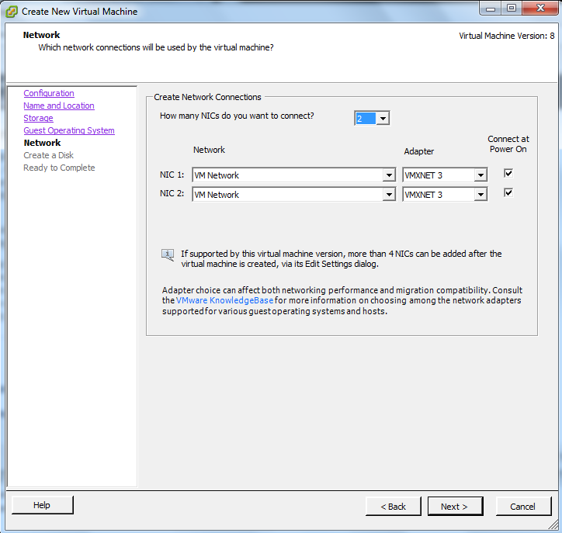

Then create a virtual disk enter the size and select the radio button as thin provision and click next

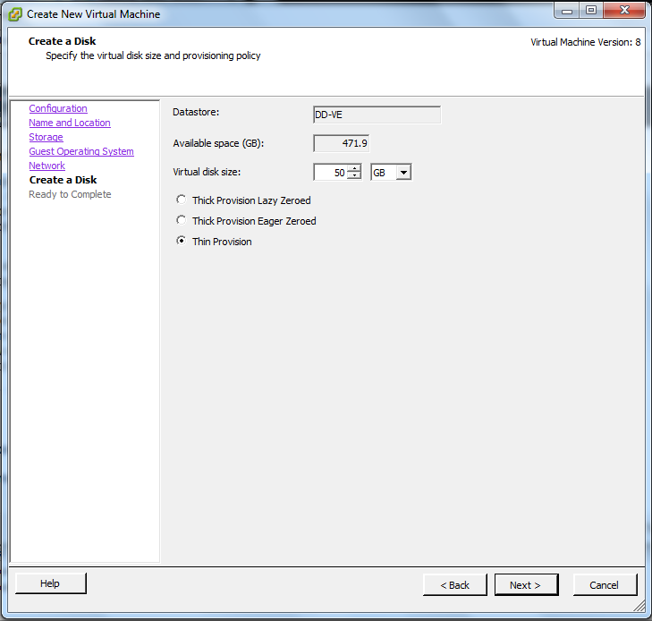

Select the check mark **edit virtual machine before completion** then click on continue, as below

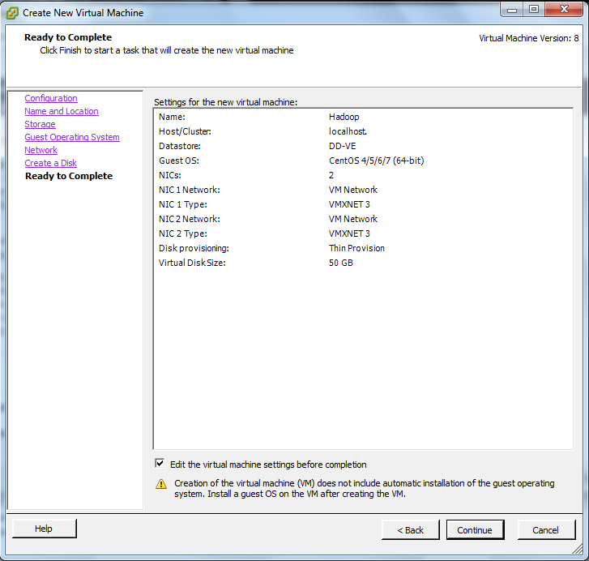

Then edit the memory size you want and click on **new CD/DVD** and select data store ISO if your image file exists in the data store and select that image file attached to your host else you can select client device. 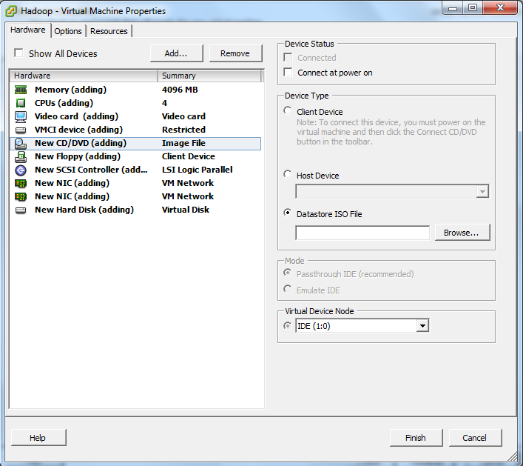

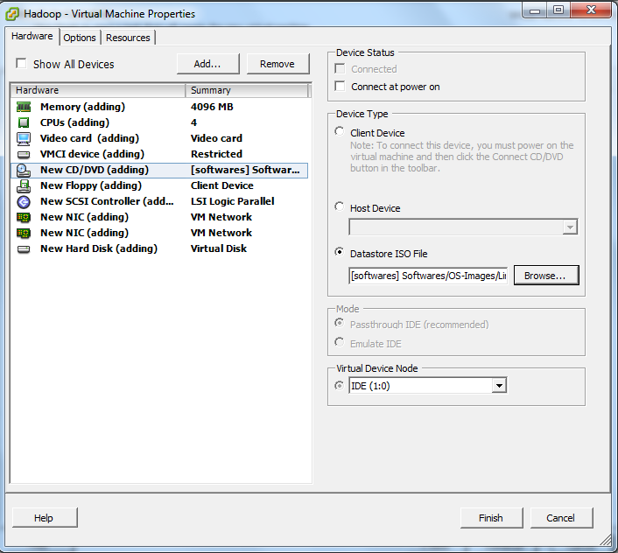

Then click on finish.

Now your able to see the virtual machine you just created and power on the virtual machine and click on console that results as follows,

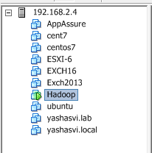

Console looks like this

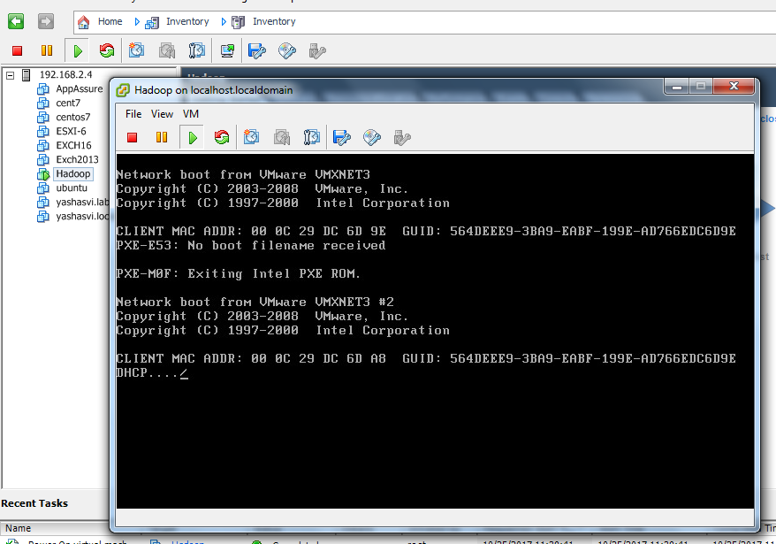

Then select the CD/DVD drive and click on connect to ISO image on data store, if your using locally then you can select connect to ISO on local disk .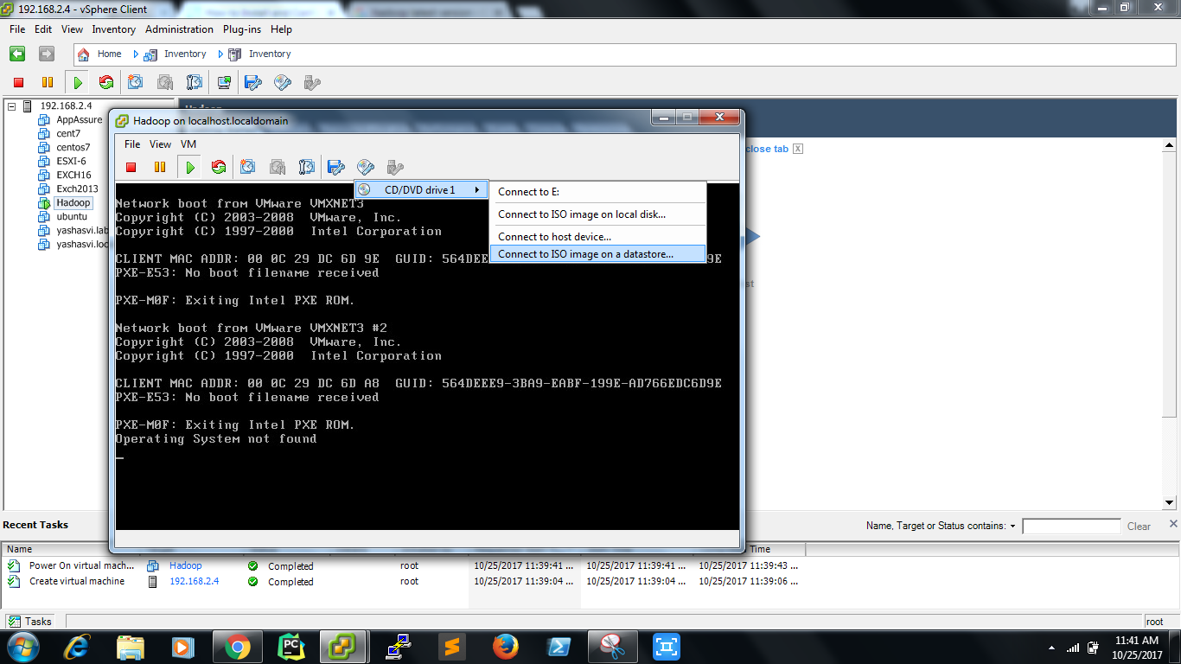

select the installation file as below.. and click ok it takes few minutes 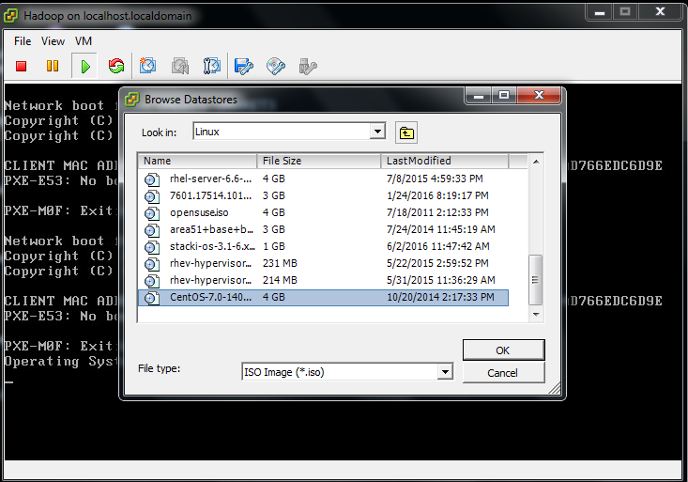

press (CTL+ALT+insert )button and it loads the installation media and results as below and select install centos 7 and press enter and it takes few minutes,

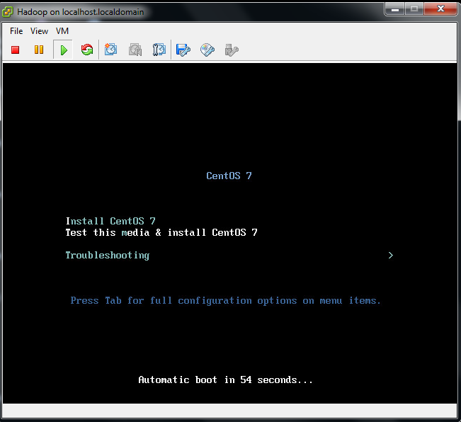

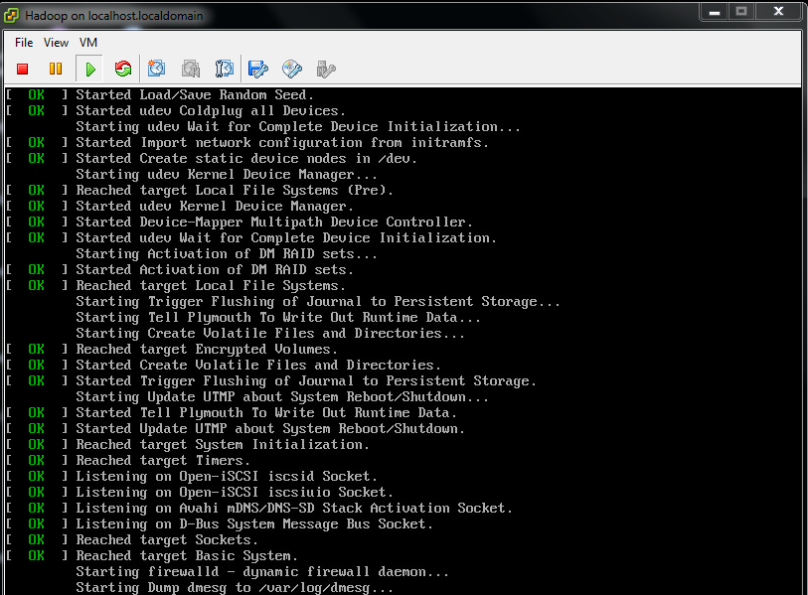

Select English and click on continue,

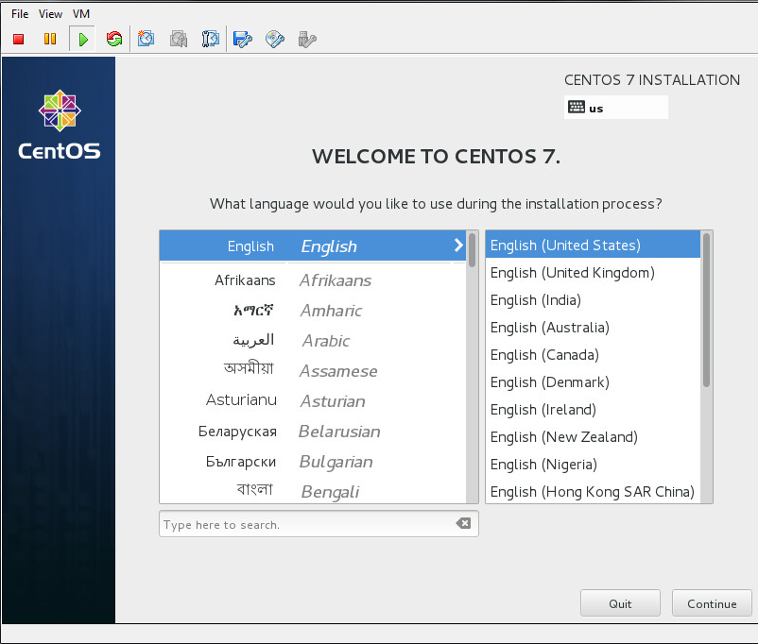

Select on server with GUI and enable the virtualization in add-ons as below,

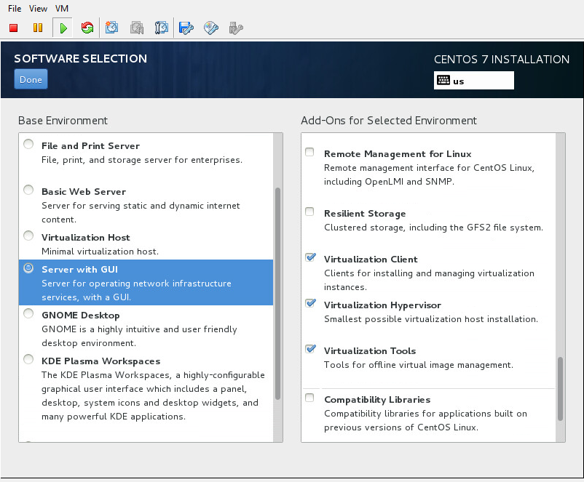

Click on done and results like below,

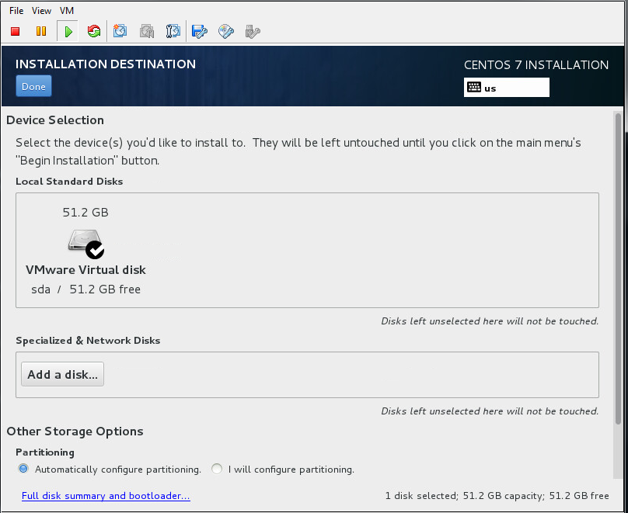

In the above diagram you can see the virtual disk you have created earlier now we need to create partition so **click on I will configure partitioning then** click done.

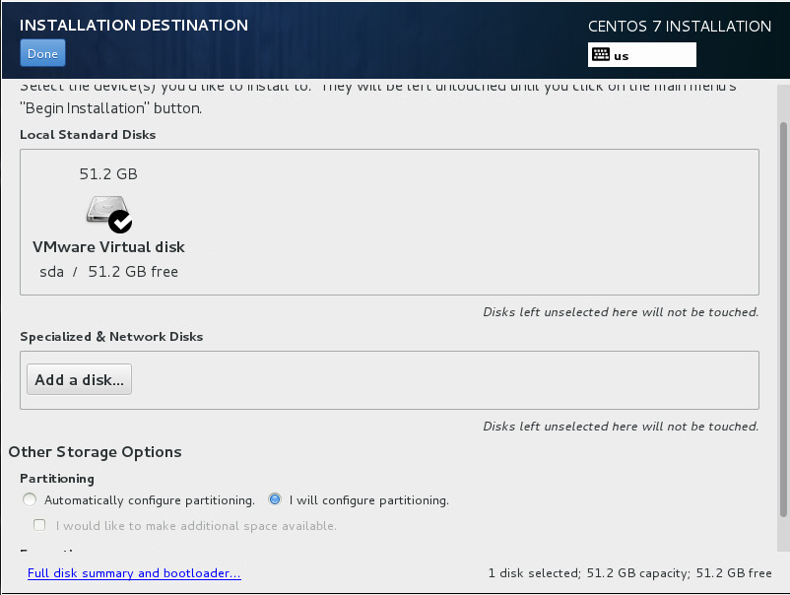

That results as below, and select standard partition then click done,

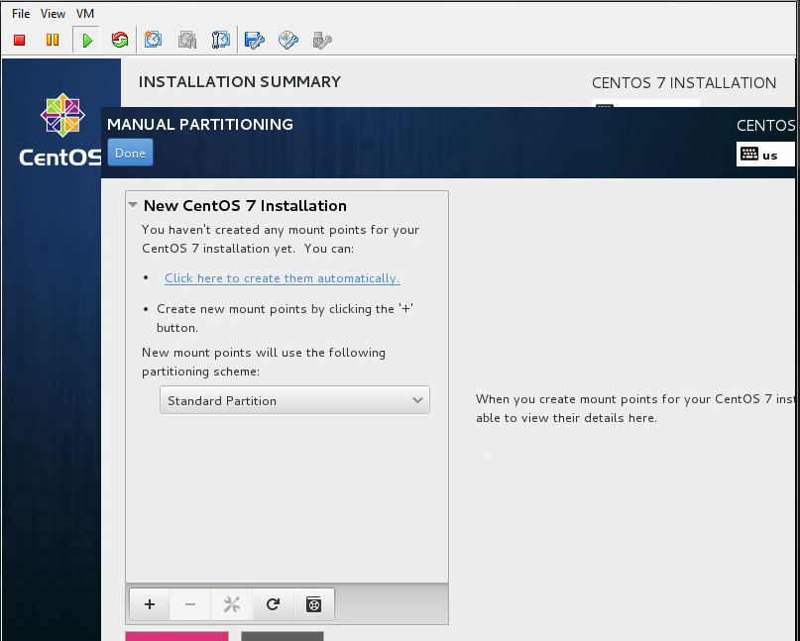

Create / root , /home , /boot ,/swap partitions as follows,

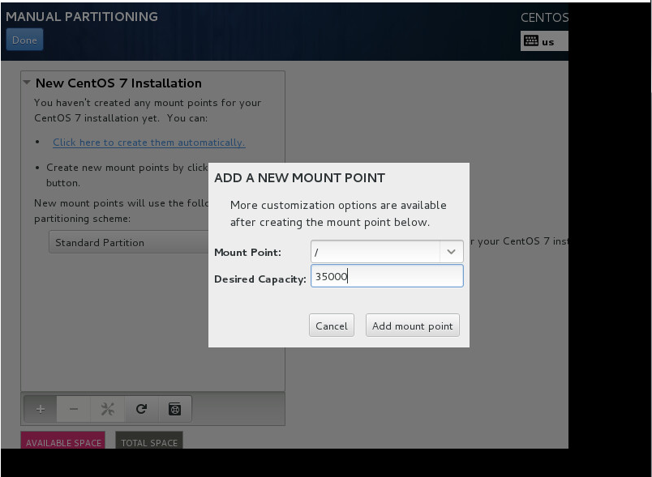

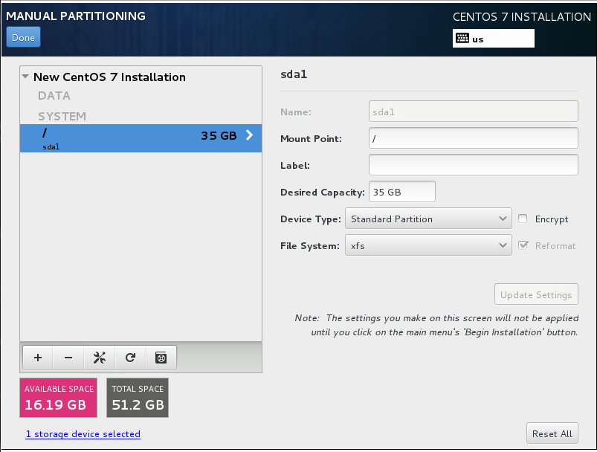

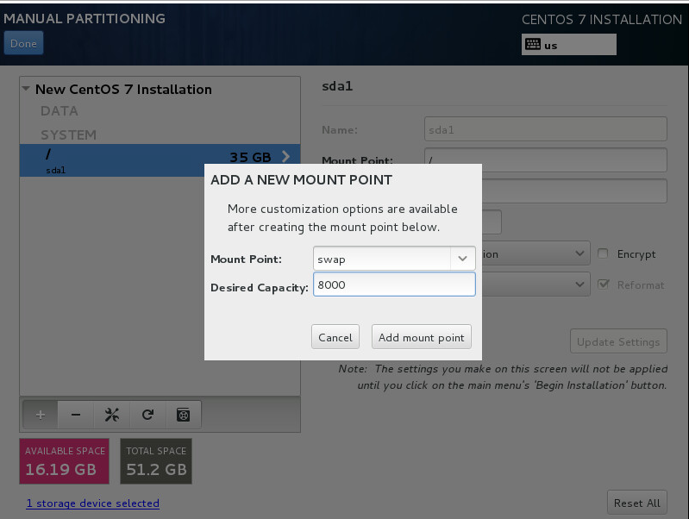

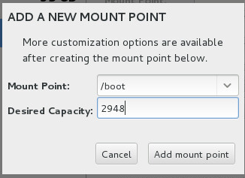

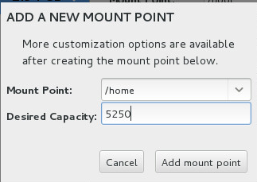

Now here you can see all the partitions.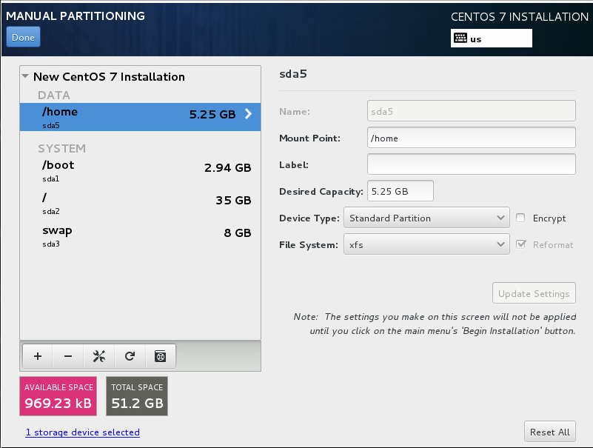

Click on done and select **accept changes** as below,

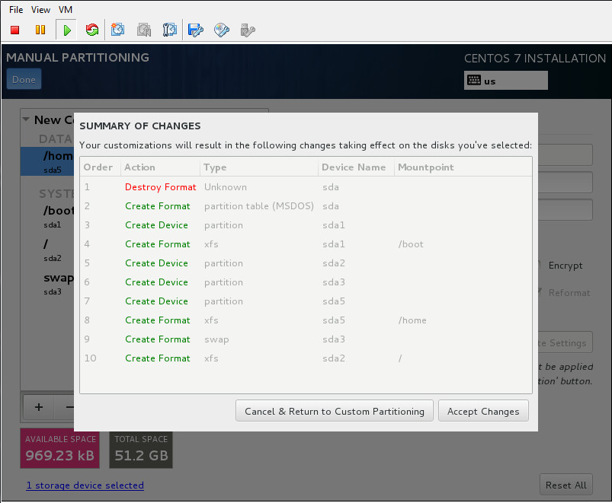

It comes here, click on begin installation.

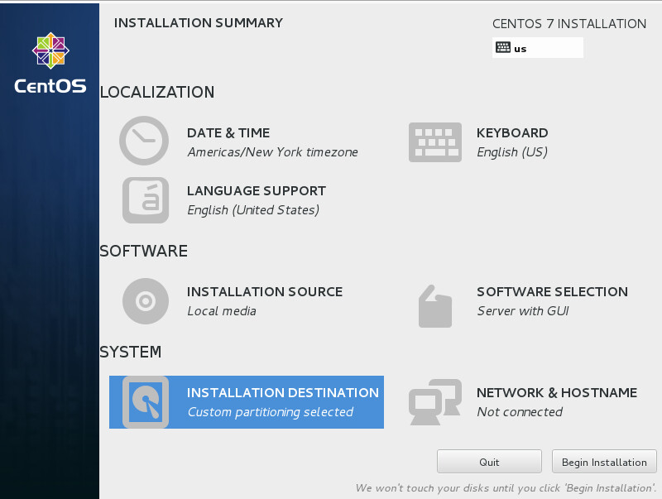

Installation begins,

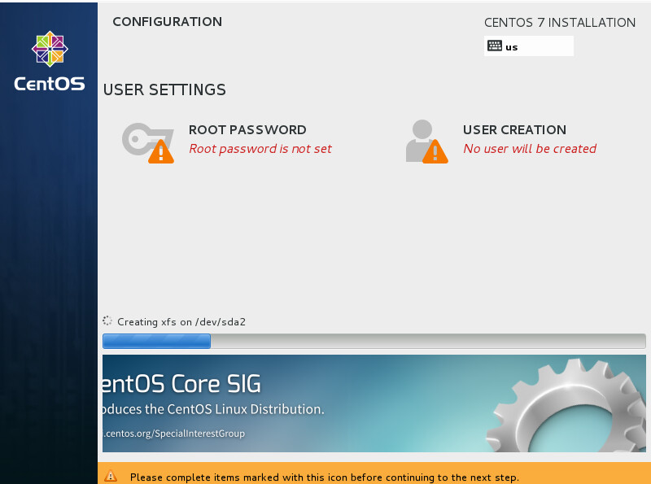

Click on root password and set the password for root and click **done**

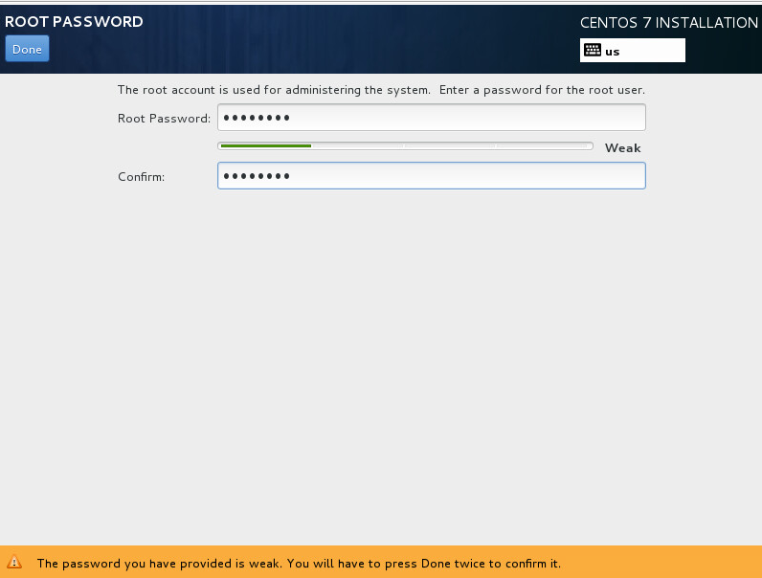

Installation takes few minutes to complete after completion click on reboot, vm will restart and loads ,

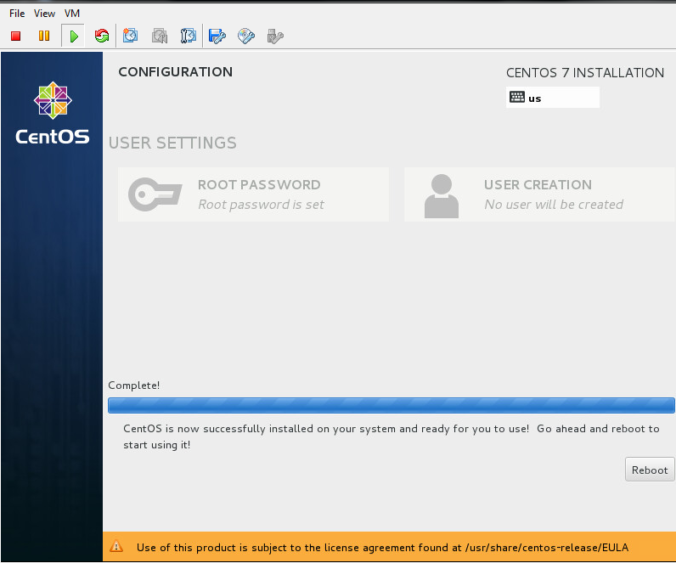

After reboot accept the license agriment and click **done**

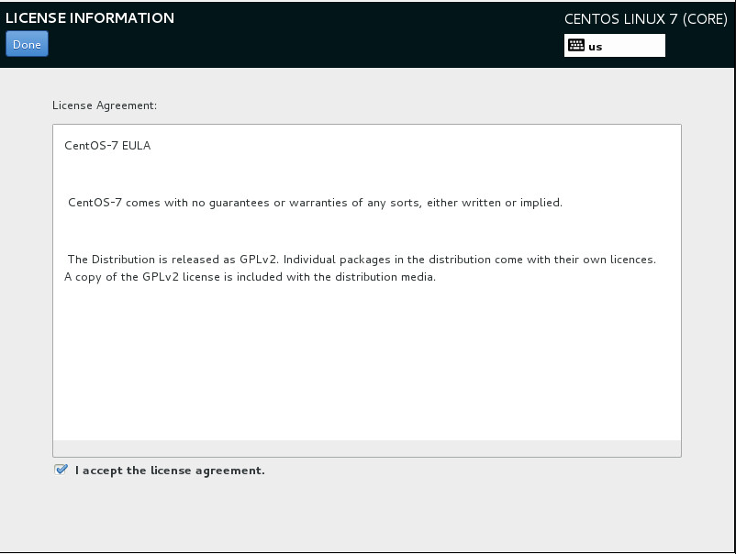

Create user and click on finish configuration,

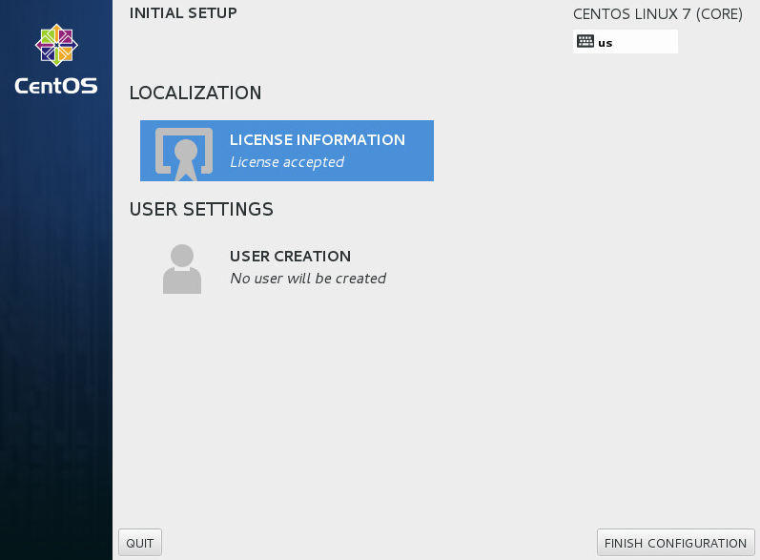

select language and click **next,**

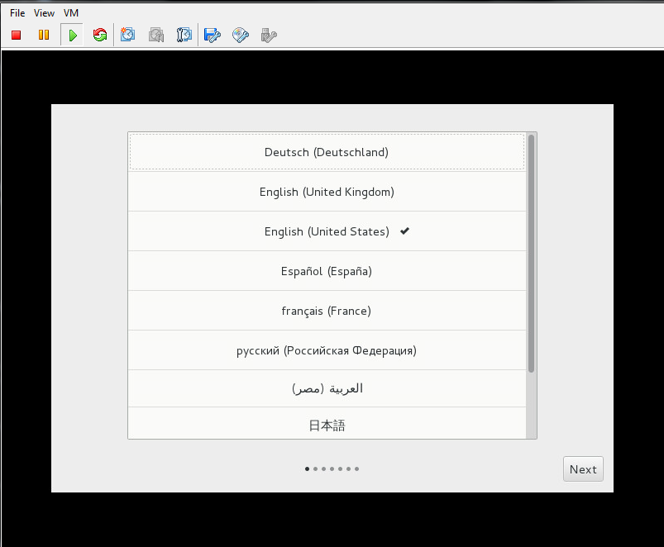

crate user and password and click next,

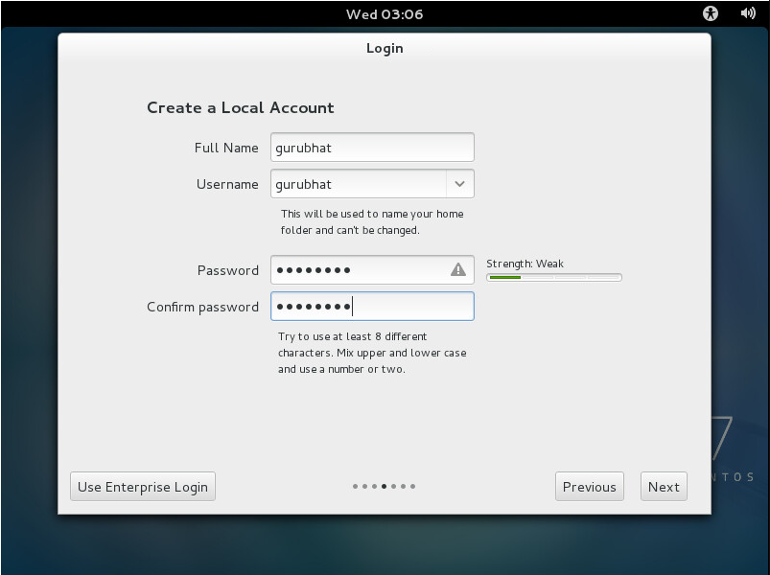

Select time zone and click next,

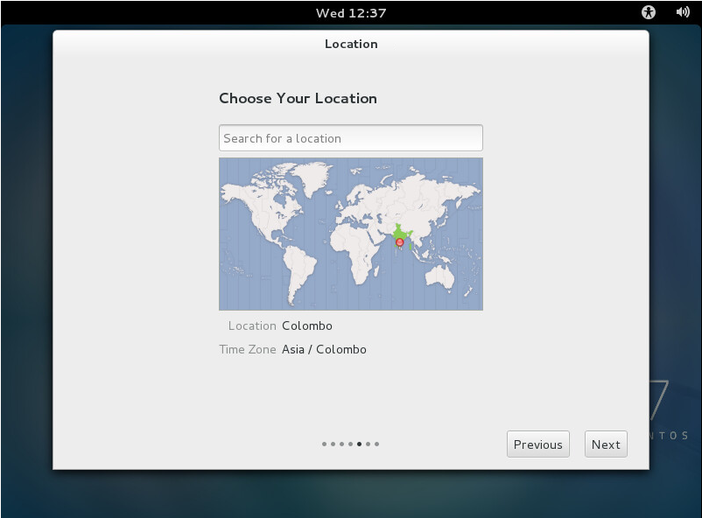

Click on start using Centos it takes you to the desktop, that’s it now you finished the installation process

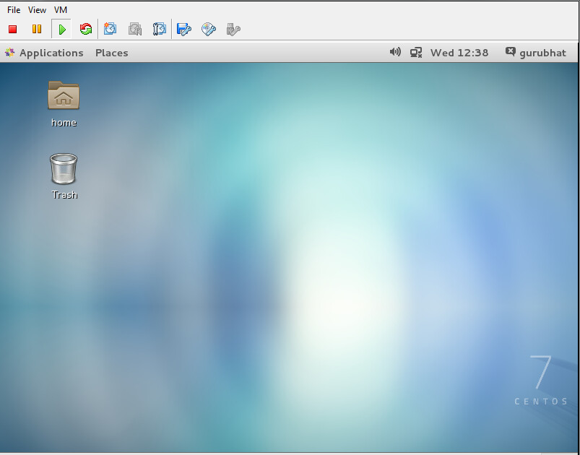

<<<<<<<<<<<<<<<<<<<<<<<<**Thank You**>>>>>>>>>>>>>>>>>>>>>>